
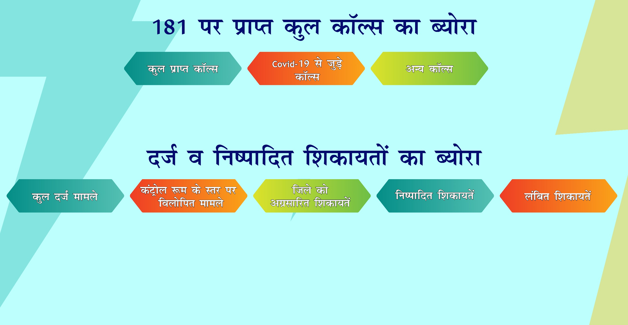
30105

55282
85387

DATE RANGE: 23-03-2020 TO 01-05-2020
55282
28342

22762
(80.31 %)

26940
5502

